**WEKA ASSIGNMENT**

**BY: AARON PULIKKOTTIL**

**1. DATASET DESCRIPTION:**

Dataset Name: Labor

Source of the dataset: https://github.com/tertiarycourses/Weka/blob/master/Weka%20datasets/labor.arff

Dataset description: The data set contains 1 classes of 57 instances each where each class refers to a type of iris plant.

No of attributes: 17

No of instances: 57

**2. INPUT & OUTPUT:**

|  |  |  |
| --- | --- | --- |
| LABOUR | 1.Duration  2.Wage increase 1st year  3.Working hours  4.Pension  5.Education allowance  6.Statutory Holidays  7.Vacation  8.Standby Pay  9.Bereavement Assistance  10.Class | Duration: class  Wage increase 1st year: class  Working hours: class  Pension: class  Education allowance: class  Statutory Holidays: class  Vacation: class  Standby Pay: class  Bereavement Assistance: class |

**3. DATA PREPARATION:**

Removal of null data types, empty instances and false attribute.

**4. SELECTING AN ALGORITHM:**

|  |  |  |
| --- | --- | --- |
| **Algorithm** | **Result from Weka** | |
| **Correctly Classified Instances** | **Mean Absolute Error** |
| **Weka Classifiers** | | |
| NaiveBayes | 51 | 0.1042 |
| NaiveBayesMultinominalText | 37 | 0.4574 |
| NaiveBayesUpdateable | 51 | 0.1042 |
| **Weka Classifiers Functions** | | |
| Logistic | 53 | 0.0641 |
| MultilayerPerceptron | 49 | 0.1524 |
| **Weka Classifiers Meta** | | |
| AdaBoostM1 | 50 | 0.1519 |
| Bagging | 48 | 0.2979 |
| **Weka Classifier Trees** | | |
| J48 | 42 | 0.3192 |
| RandomTree | 45 | 0.2438 |
| **Weka Classifier Rules** | | |
| DecisionTable | 43 | 0.2996 |
| JRip | 44 | 0.2256 |

**5.DATA PREPROCESSING:**

|  |  |
| --- | --- |
| **Attribute Evaluator** | Classifier Subset Eval (Classifier: meta.Bagging with training parameter: classifiers = J48 and the others in their default) |
| **Search Method** | BestFirst (Direction: Forward) |
| **Evaluation Mode** | 10-fold cross-validation (Folds = 10, Seed =1) |

**6.TREE PRODUCED:**

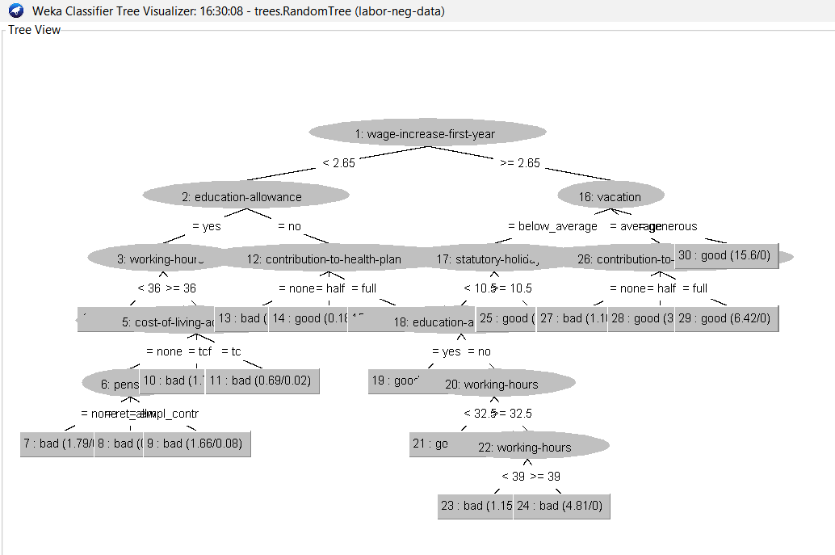

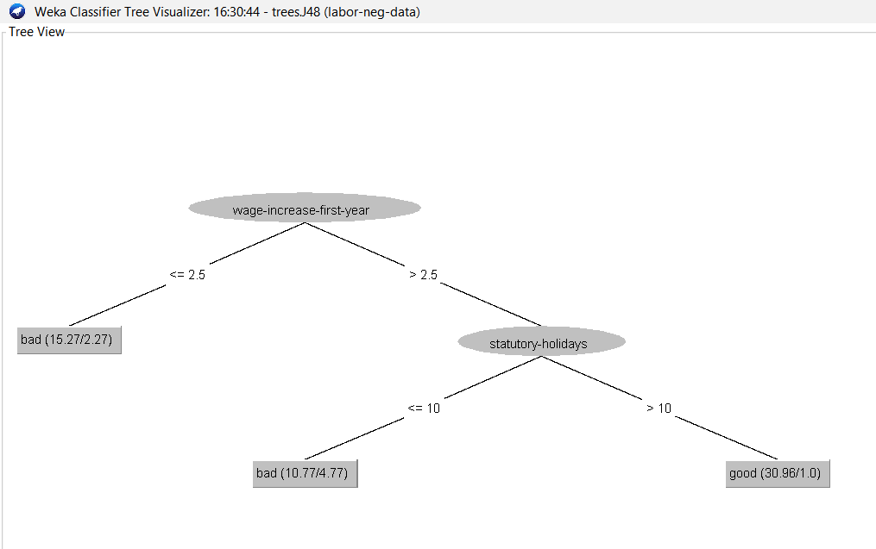

**7. SCREENSHOTS:**

